High School Sailing Handbook
2015/2016

All students 13 to 18 years of age are invited to participate in our High School Sailing Program. The Chautauqua Lake Community Sailing Foundation facilitates sailing for these students by providing coaching, sailboats, and coach boats.

“To Promote A Lifelong Love Of Sailing”

Purpose

This goal of the handbook is to assist high school sailors and their parents in understanding the structure and operation of the High School Sailing program at Lakewood Beach. Regular updates are added as changes and improvements are needed. Feel free to contact the Sailing Director if you wish to contribute to this process.

Eligibility

The program is open to full time students, girls and boys, at the local high schools in the surrounding areas, between the ages of 13 and 18. It is recommended that each high school student wishing to compete in regattas be a member of the Inter-Scholastic Sailing Association (ISSA). For more information, check out the ISSA site at www.hssailing.org.

Liability Form
The Release of Liability form is located at the back of this manual. Please return the signed form on or before the first day of practice. Without this form, you will not be able to sail. A calendar of events is on the ISSA site (http://massa.hssailing.org). Payment of fees is due by the first day on the water.

Summer Practice Schedule

Beginning Teen Sailing
Monday through Friday – 1pm to 4pm. This program is for beginner and novice sailors to learn the basic principles of sailing, and to participate and become proficient in racing.

Intermediate and Advanced Teen Sailing and Racing
Monday through Friday – 4pm to 6pm. This program is for experienced sailors to learn advanced sailing techniques, racing instruction, and limited racing. These sailors will hone their skills and advance to compete in High School events.

Fall Practice Schedule

High School Sailing
Monday through Thursday - 4pm to 7pm. This is a co-ed program, lasting 8 weeks. Local high school students will participate in racing instruction, with a race series every Thursday. The top sailor will advance to regional regattas and potentially nationals.

Structure of Teams and Competition within MASSA

Organized high school sailing started in 1930 in New England. Today it is experiencing a tremendous growth throughout the United States.

High School Sailing is governed by the Interscholastic Sailing Association (ISSA) at the national level, and is broken down into seven districts around the United States. We sail in the Mid Atlantic Scholastic Sailing Association (MASSA) District, which is comprised of schools from upstate New York to Virginia. Each team MUST be a member to ISSA to compete in high school regattas.

MASSA is further broken down into four leagues, North West, North East, Central, and Southern. Throughout the high school season, teams will compete in both league events and MASSA district events. The results from these events are used to determine a rank in the Central League standings. This is used to decide who is eligible to attend the MASSA Championships, and the top teams in the spring qualify for the National Championships.

A sailing team is made up of the team members, its team captain(s) and an advisor from the school and/or a parent. Sailors are generally classified as skippers (in charge of steering the boat) and crews (who trim the jib and act as the eyes for the boat). The designation of crew or skipper is not rigid, and will be determined by the coach. Throughout the season, the coach will work to create skipper/crew combinations that are congruent with the team's goals and have a positive chemistry between the individuals. During both practice and regattas, the coach will make decisions as to the combinations and which division a boat is sailing. Team Captains, Team Advisors, and parents do not determine who skippers, crews, or the sailing combinations. Coach decisions are final.

Not every sailor is able to attend each regatta. Sailing is a unique sport in that only a small number of team members can participate in a single regatta. Further, conditions may prevent lighter or heavier sailors from sailing on a given day, regardless of their ability, age, or hierarchy on the team. When the coach determines who is sailing in an event, we will take into consideration practice attendance and their attitude towards the team. Players who take the team seriously, and are willing to help keep the team running smoothly are more likely to be considered to compete in events.

The team captain is an important role on the team. Their job is to make sure that all lines of communication are open among the players, the coach, and the team advisors. This ensures that there is proper communication, and will keep the team running well, as well as allowing us to continue to improve. Not only is the captain helping communication, they also need to be a leader and an organizer of the other players.

The team advisor or parent works with the team captain and coach in organizing travel logistics to regattas. Ideally, there should be many parents active in this process. ISSA rules stipulate that there must be a team chaperone from each team present at each regatta. It is advisable to find adults and sailors alike who can commit to these events well in advance. If the parent who committed to the event cannot fulfill their obligation, then it is their responsibility to arrange for a suitable replacement. The role of the parents at the regatta is to be a chaperone and not to coach the sailors. The coach’s role at the regatta is strictly to coach.

High school sailing has three different types of racing:

Fleet Racing- This is the most common format of racing in high school. All schools have an “A” and a “B” division boat. All of the boats in one division will race against each other. The team’s score is a combination of points from both divisions, and the team with the lowest points wins the event.

Team Race- In a team race, two schools compete against each other at one time. Both schools have three boats on the water. The goal is to have your three boats finish in a better position than the other team’s boats. Regattas are generally run in a round robin format, and the team with the best win-loss record is the winner.

Single-handed- This is sailed in boats with only one person, and is run in the same format as fleet racing. The single-handed nationals for The Cressy Trophy are raced in Laser Radials and Full-Rigs in the fall.

Z420

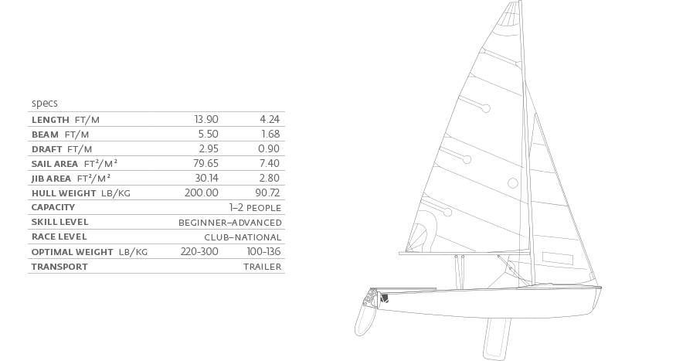
The CLCSF fleet is made up of 12 Z420s.

The Z420 is a more modern and thoughtful upgrade from the Club 420, adding new ideas to a boat originally designed in 1959. The new LaserPerformance collegiate Z420 has been designed to ensure the future success of collegiate sailing through the collaborative efforts of many college coaches.

The results are distinctly evident when sailing the Z420. The development team was able to shave weight of the existing C420 hull and still make the hull 40% stiffer– so the levels of performance have completely jumped off the charts. The Z420 is also eminently more seaworthy because of its larger, enclosed, air-tight, forepeak which provides a higher level of safety.

The Z420 boasts an integrated bow bumper, a keelson that is angled to account for the human factors involved in roll tacking, side tanks that have been angled to improve crew comfort and increase internal air volume, an angled and reinforced centerboard trunk cap for strength and ergonomics, increased radii in all corners to increase strength and rigidity of the structure and much more.

The hull and deck employ a modern laminate schedule that utilizes a ballistic core for both stiffness and durability. The Z420’s keelson is a solid closed cell foam structure that is “insert molded” in place when the boat is manufactured. Utilizing the infusion process, the Z420 has a solid backbone giving it strength from stem to stern. It is built to endure.

Equipment/clothing/gear

The Chautauqua Lake Community Sailing Foundation provides teams with sailboats and all the necessary equipment. CLCSF is not responsible for supplying flotation devices or cold weather clothing. It is up to each sailor to arrive at practice equipped with a coast guard approved life jacket and proper sailing clothing for the conditions.

For safety reasons, the coach will insist that sailors be properly attired. Regardless of the season, hypothermia can occur in a matter of minutes if a sailor capsizes and is improperly dressed. A sailor with the right clothing will be able to continue sailing in comfort after multiple capsizes while minimizing their risk of hypothermia. The coach reserves the right to refuse sailing to sailors who are not prepared for the conditions. This is in the interest of their safety.

Insulation and wind protection are the key elements to sailing clothing. Dinghy sailing is an active sport and you will work hard and generate a lot of body heat. For this reason, it is important to dress in a way not to overheat. It is also equally important to dress in a manner to be comfortable after getting wet from spray and/or capsizes. Avoid cotton at all costs. T-shirts, sweatshirts, jeans, etc are the worst kind of clothing for sailing as they retain water, restrict mobility, and actually make you colder.

- Closed toed shoes are required. Dinghy boots are preferred but sneakers will do. No flip-flops or bare feet!
- If you are planning to wear shorts while sailing, please no soccer or mesh shorts. They get in the way and have a tendency to fall down. Board shorts or spandex shorts are more suitable.
- Full body coverage; either a wetsuit or foul weather jacket and pants with an insulation layer beneath. The insulation layer should be something that will not lose its insulation properties when wet. Consider capilene, spandex, and fleece. When the water gets colder, and the possibility of capsizing is more likely, consider wearing more layers and possibly a dry suit.
- PFD (Personal flotation device). No one is permitted on the water without wearing a proper lifejacket (PFD). Aside from fitting properly, the PFD needs to be comfortable and allows for freedom of movement. There are a number of PFDs specifically designed for dinghy sailing.
- In colder weather, sailors should wear a hat that insulates and stays on in the breeze. Keeping your head covered greatly improves comfort and minimizes chances of hypothermia on a cold day. It is also important to bring a hat even on warmer days, because it will help you stay more comfortable near the end of practice.
- Sailing gloves protect against chafing. They are not strictly necessary but are good to have. Gardening gloves are sometimes used because of their grip, and dishwashing gloves are worn over liners when the water gets cold.
- Sunglasses are extremely important on the water to protect the sailor’s vision, not only from spray but from glare and sun exposure. Sunglasses also help to better see wind lines on the water as well.
- Pinnies. The purpose of pinnies is to identify each school on the water, and make viewing easier for spectators. The club will purchase these, and each sailor will buy it from the club. The pinnies will be specific to each school.

Travel

As indicated above, the primary responsibility for travel arrangements to regattas lies with the sailors, the team parent, and the sailor's parents. A realistic goal is to have the team roster set two weeks ahead for away events. Sometimes, due to qualification and ranking data this is not possible.

The coach will try to organize team rosters with the two-week planning ranges in mind. It is the sailor’s responsibility to obtain parental permission to travel to events, and if necessary, the coach will help with reminders. There is no reason for a sailor or a parent not to know about an up and coming event (http://massa.hssailing.org).

Attendance is critical leading up to regattas to ensure the rosters can be formed. The coach asks that as soon as a sailor knows about a date when they have obligations, to inform the coaches, so that the coaches can determine a roster for practice and each event. If it is found during the day that a sailor is not able to make it to practice, please inform the coaches before noon, so that changes can be made.

The financing involved in team travel is determined by each team, and should be set up by the parents and team advisor. Parent should always make sure that individual sailors are properly funded for food and incidentals before they depart. The coaches will not lend sailors money if they are not prepared. It is not the coaches’ responsibility to insure that each sailor has money for the event. Prior to departure, parents are free to call the team parent or other parents and ask about meal arrangements and other items that may require personal expenditure.

